800-803-7174
AM I ELIGIBLE FOR Medicare Discount PROGRAMS?

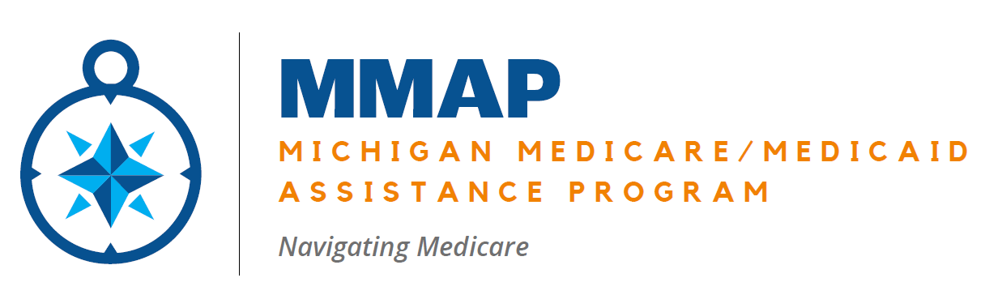

DO I QUALIFY FOR EXTRA HELP WITH MY PRESCRIPTION DRUG PLAN?
(Low Income Subsidy or Extra Help)
IS MY GROSS MONTHLY INCOME LESS THAN 1,902 YES / NO
Or (if married)
IS OUR MONTHLY INCOME LESS THAN 2,575 YES / NO
IF YOU CHECKED YES CONTINUE
ARE MY ASSETS (EXCLUDING HOME AND CAR) LESS THAN 17,220 YES / NO
OR (IF MARRIED)
ARE OUR ASSETS (EXCLUDING HOME AND CAR) LESS THAN 34,360 YES / NO
IF YOU CHECKED YES, YOU MIGHT QUALIFY FOR EXTRA HELP!

=============================================================================================

DO I QUALIFY FOR MI TO HELP PAY MY FEDERAL MEDICARE B PREMIUM?
(Medicare Savings Program/ MSP)
IS MY GROSS MONTHLY INCOME LESS THAN 1,714 YES / NO
OR (IF MARRIED)
IS OUR MONTHLY INCOME LESS THAN 2,319 YES / NO
IF YOU CHECKED YES CONTINUE
ARE MY ASSETS (EXCLUDING HOME AND 1 CAR) LESS THAN 9,430 YES / NO
OR (IF MARRIED)
ARE OUR ASSETS (EXCLUDING HOME AND 1 CAR) LESS THAN 14,130 YES / NO
IF YOU CHECKED YES, YOU MIGHT QUALIFY FOR THE MEDICARE SAVINGS PROGRAM!

