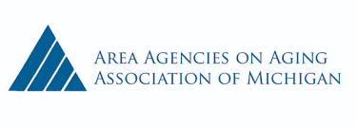
June 24, 2020
The Honorable
House of Representatives
P.O. Box 30014
Lansing, MI 48909-7514

Dear Representative
It is more important now than ever that Michigan seniors have continued access to effective in-home & community-based services to remain independent in their homes. While persons age 60 and older comprise 24% of the Michigan population, they make up 34% of the MDHHS reported COVID-19 cases. Most tragically, persons 60 plus represent 84% of the pandemic deaths reported according to Michigan Department of Health & Human Services. Michigan seniors remain at high risk of infection and death and face a much longer period of social isolation.
The aging network consists of more than 1,300 service providers that directly deliver an array of supports and services to more than 250,000 seniors and persons with disabilities annually across the state. Currently, service providers have been experiencing decreased revenue and increased costs, while also receiving increased requests for assistance.
The Area Agencies on Aging Association and our Aging Network Partners recommend that you:
- Protect and hold harmless services to seniors and persons with disabilities in the FY 2020 and FY 2021 state budgets.

- Increase the pay for direct care workers both in the short-term for COVID-19 response efforts and in seeking longer-term permanent solutions to sustain these increases. We strongly support the $226.5 million temporary pay increase for direct care workers included in SB 690 (H-2). Direct care workers are essential to effective in-home and community-based senior services. They have placed themselves and their families at risk in serving Michigan seniors during the pandemic and deserve our strongest support and gratitude.

Part of our strategy to re-engage the economy and transition beyond lockdowns must include adequate protections and care for vulnerable populations. We thank you for helping Michigan seniors during this pandemic and beyond.
Sincerely,

