Social Media Posts
Senior Action Week May 9-13, 2022

Hashtags:
#ActionForSeniors
#AgingStrong

Post 1: Monday
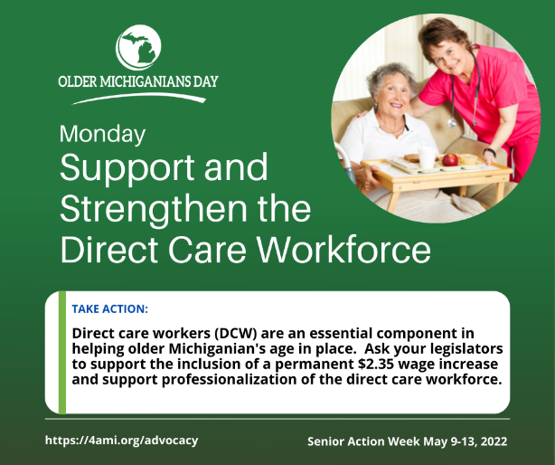
#AgingStrong is made possible by our direct care workforce who are everyday heroes to older adults. Take #ActionForSeniors by supporting a permanent wage increase and professionalization of this essential workforce.

Post 2: Tuesday
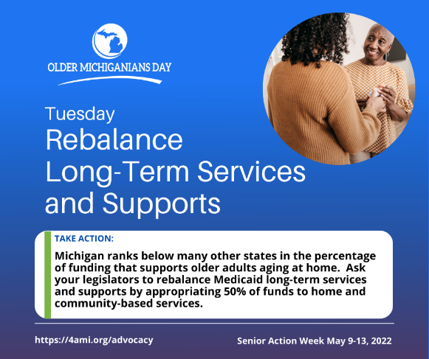
Urge the #MichiganLegislature to take action to rebalance Medicaid long-term services and supports in Michigan by appropriating at least 50% of funding to home and community-based services. #ActionForSeniors

Post 3: Wednesday
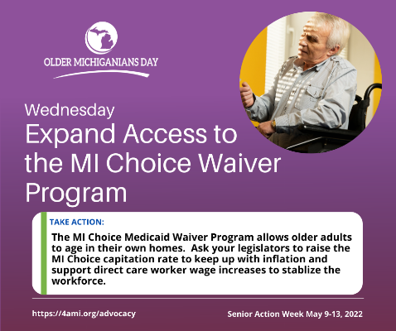
We urge the #MichiganLegislature to take #ActionForSeniors by protecting MI Choice funding and raising capitation rates. MI Choice has demonstrated that care delivered in the home is 42% less expensive than having the same person moved into an institutional setting.
Post # 4 Thursday
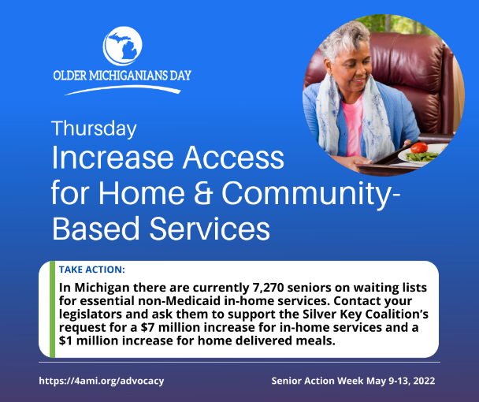
Urge the #MichiganLegislature to take #ActionForSeniors by protecting in-home and community-based services in the FY2023 budget. Older adults need our help more now than ever! #AgingStrong means aging with dignity and independence!

Post # 5 Friday
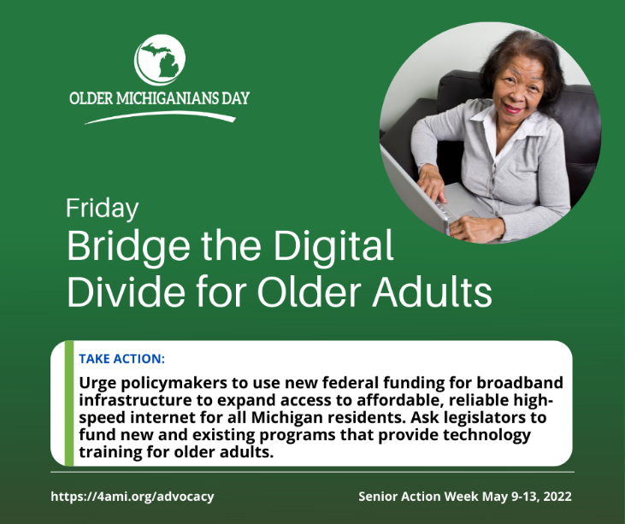
Lack of access to the internet and technology increases social isolation even though there are many programs to keep older adults safely connected. Urge #MichiganLegislators to fund broadband access to help older adults continue #AgingStrong.

